Blackjack
Software Requirements Specification

Manny Gonzales, Nick Vu, Paul Cooper
https://github.com/eb-heavybarrel/CS401_Blackjack
Revision History

Date | Revision | Description | Author
02/16/2026 | 1.0 | Initial Version | Paul Cooper
02/23/2026 | 1.1 | Definitions (1.2) & Overview (1.4) Updated | Nick Vu
02/24/2026 | 1.2 | Refined definitions | Nick Vu
03/01/2026 | 1.3 | Added additional definitions. Filled in some requirements in sections 2.4,2.5,3.2,3.3,4.2,4.3 | Paul Cooper
03/02/2026 | 1.4 | Added product perspective (2.1) and product functionality/features (2.3) | Nick Vu
03/04/2026 | 1.5 | Added 3.1.8 | Manny Gonzalez Cashun
03/04/2026 | 1.5.1 | Added 3.1.5, cleaned formatting and entries for sections 3 and 4 | Nick Vu
3/04/2026 | 1.6 | Added names, fixed formatting, add use case diagram | Paul Cooper
3/04/2026 | 1.6.1 | Added requirements to modules 3.1.6 and 3.1.7. | Manuel Gonzalez Cashun
03/04/2026 | 1.7 | Added requirements to 3.1.2, 3.1.3, 3.1.4, and 3.1.5. Reworked 3.2 | Nick Vu
03/04/2026 | 1.8 | Added Sequence Diagrams | Paul Cooper
03/04/2026 | 1.9 | Added Class Diagram | Nick Vu
03/04/2026 | 1.10 | Added Case specification | Paul Cooper

Table of Contents
1. Purpose iv
1.1. Scope iv
1.1. Definitions, Acronyms, Abbreviations iv
1.2. References v
1.3. Overview v
2. Overall Description vi
2.1. Product Perspective vi
2.2. Product Architecture vi
2.3. Product Functionality/Features vi
2.4. Constraints vi
2.5. Assumptions and Dependencies vi
3. Specific Requirements viii
3.1. Functional Requirements viii
3.1.1. Common Requirements: viii
3.1.2. Users Module Requirements: viii
3.1.3. Datastore Module Requirements: viii
3.1.4. Network Module Requirements: viii
3.1.5. GUI Module Requirements: viii
3.1.6. Lobby Module Requirements: viii
3.1.7. Table Module Requirements: viii
3.1.8. Game Module Requirements: viii
3.2. External Interface Requirements ix
3.3. Internal Interface Requirements ix
4. Non-Functional Requirements x
4.1. Security and Privacy Requirements x
4.2. Environmental Requirements x
4.3. Performance Requirements x

Purpose
This document outlines the requirements for the Blackjack Handling System (BHS).

Scope
This document will catalog the user, system, and hardware requirements for the BHS system. It will not, however, document how these requirements will be implemented.

Definitions, Acronyms, Abbreviations
Player: A user role that can participate in Blackjack games, and participate in standard game actions such as betting, hit, stand, and folding/surrendering
Dealer: A specialized user role with the added ability to operate as a dealer for the games and the configurator of game parameters when creating joinable tables for blackjack, deals cards in accordance to standard blackjack rules
User: Either a player or a dealer, generally used before the system has identified the individual during the login phase.
Hand: A collection of cards assigned to a player or dealer during a round of Blackjack, which changes based on gameplay actions and outcomes
Table: The instance of a game in a lobby, up to six players including the hosting dealer
Lobby: An area of the Blackjack program where tables are viewable for players to join or for dealers to create a table
Round: A cycle of player betting and playing in a blackjack game between the betting and outcome phases
Game phase: Distinct phases for player betting, dealing and actions, and outcome
Payout: A specific outcome for a player to be paid out the appropriate bet they won against the dealer
Deck: A standard set of 52 cards used to interact with the gameplay
Card: A singular card from a standard deck of 52 cards, categorized by suit and rank value
Shoe: A collection of multiple decks used in the Blackjack games
Bet: A number of credits submitted by a player before being dealt hands to start playing the game
Timer: A countdown for the time players have to take action in a round of the game
Credits: Virtual currency with a 1-to-1 conversion with player dollars from their payment method attached to their account, used in bets for games
Credit Card (CC): A player user’s payment method for credits
Blackjack Handling System (BHS): The software responsible for handling the blackjack game functions and logic, network connectivity for players to the server, as well as player interactions and active games
Graphical User Interface (GUI): The visual interface players use to interact with the BHS
Server: The program responsible for allowing multiple client programs to connect, allowing users to play blackjack games against each other over a network connection, receives player actions and enforces game rules with network communication between clients
Client: The program used by players to connect to the server program for connection to blackjack games over a network connection, sends actions to the server
Soft hand: When a player or dealer has an ace whose current value is 11. Standard blackjack rules require the dealer to hit when they have a soft 17 or less.
Hit: When a player requests an additional card from the dealer.
Stand: When a player signals they don’t want any additional cards dealt to them during the current round.
Double down: When a player asks for one more card to be dealt to them that round while also doubling their current bet.
Split: When a player has matching cards, they can pay to have their hand divided into two separate hands. The dealer will then deal each hand an additional card to bring the total cards in each hand to two.
Bust: When the hand value of either the player or the dealer goes above 21, resulting in an automatic loss.
Push: When the dealer and the player end the round with the same hand value and all bets are returned.
Win: When the player ends the round with a higher hand value than the dealer.
Lose: When the player ends the round with a lower hand value than the dealer, or they bust.
Insurance: When a dealer is showing an ace in their hand, the players are offered the option to pay 50% more to protect their hands. If the dealer does have a blackjack, the bets are returned to the players that opted for insurance. If the dealer does not have a blackjack, the additional money goes to the house.
House: the organization the dealer works for. All bets are either covered by the house if the dealer loses or paid to the house if the player loses.
Shuffling: when the order of the cards in the shoe are randomized.

References
1.2.1 Use Case Specification Document
Use Case ID: | C01 | Use Case Name: | Player Account creation
Primary Actor: | Player | Related Use Cases: | C02
Relevant Requirements:
Pre-conditions: | Need client and server IP address
Post-conditions: | Player has a user account
Basic Flow or Main Scenario: | 1. launch client  2. select "create account"  3. enter desired username and password  4. click "submit"
Extensions or Alternate Flows: | 0
Exceptions: | Need to retry is username already exists

Use Case ID: | C02 | Use Case Name: | Player Login
Primary Actor: | Player | Related Use Cases: | C01
Relevant Requirements: | Need exsiting account
Pre-conditions: | Need client and server IP address
Post-conditions: | Player is placed into server lobby
Basic Flow or Main Scenario: | 1. Enter username and password  2.Clcik "submit"
Extensions or Alternate Flows: | 0
Exceptions: | Need to retry is username or password are incorrect

Use Case ID: | C03 | Use Case Name: | Dealer Login
Primary Actor: | Dealer | Related Use Cases: | 0
Relevant Requirements: | Need exsiting account, as a dealer these credentials are created for them
Pre-conditions: | Need client and server IP address
Post-conditions: | Dealer is placed into a Table
Basic Flow or Main Scenario: | 1. Enter username and password  2.Clcik "submit"
Extensions or Alternate Flows: | 0
Exceptions: | Need to retry is username or password are incorrect

Use Case ID: | C04 | Use Case Name: | Player Add Funds
Primary Actor: | Player | Related Use Cases: | 0
Relevant Requirements: | Logged into client
Pre-conditions: | Logged into client
Post-conditions: | Player has additional funds to play with
Basic Flow or Main Scenario: | 1.enter amount to add to account  2. Click "submit"
Extensions or Alternate Flows: | 0
Exceptions: | 0

Use Case ID: | C05 | Use Case Name: | Player Cash Out
Primary Actor: | Player | Related Use Cases: | 0
Relevant Requirements: | Logged into client
Pre-conditions: | Logged into client
Post-conditions: | Player has remove part or all of their available funds
Basic Flow or Main Scenario: | 1.enter amount to withdraw from account  2. Click "submit"
Extensions or Alternate Flows: | 0
Exceptions: | 0

Use Case ID: | C06 | Use Case Name: | Player enter Table
Primary Actor: | Player | Related Use Cases: | 0
Relevant Requirements: | Logged into client
Pre-conditions: | Logged into client
Post-conditions: | Player has moved to a table an is ready to start playing
Basic Flow or Main Scenario: | 1. Double click on desired table to join
Extensions or Alternate Flows: | 0
Exceptions: | 0

Use Case ID: | C07 | Use Case Name: | Dealer Table settings
Primary Actor: | Dealer | Related Use Cases: | 0
Relevant Requirements: | Logged into client
Pre-conditions: | Logged into client
Post-conditions: | Dealers table is ready to accept players.
Basic Flow or Main Scenario: | 1. Select Betting limits option  2. Select turn timer option  3. Select shoe size option  4. Click "Open Table"
Extensions or Alternate Flows: | 0
Exceptions: | 0

1.2.2 UML Use Case Diagram
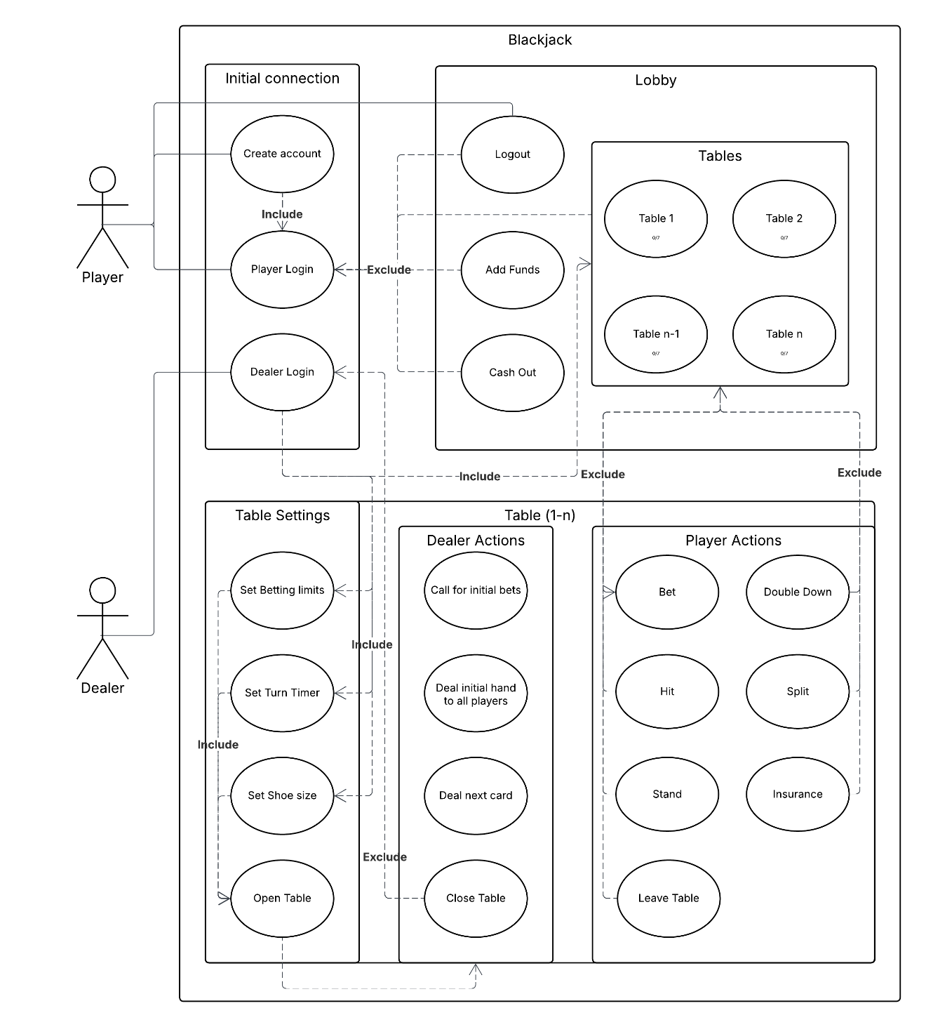
1.2.3 Class Diagrams – Step 5 in assignment description
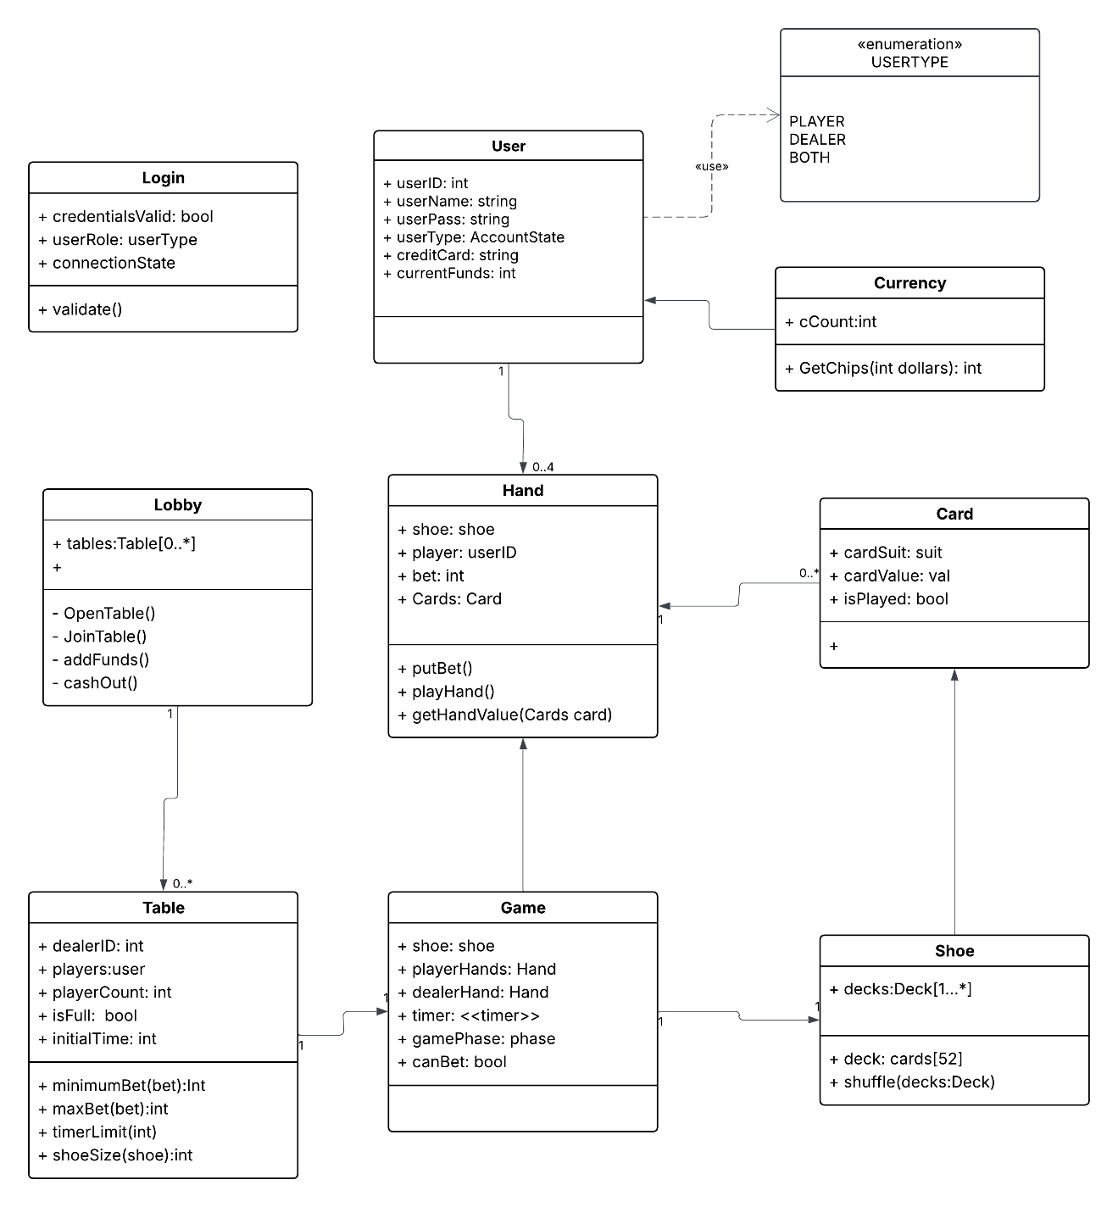
1.2.4 Sequence Diagrams – Step 6 in assignment description
1.2.4.1: User Creation
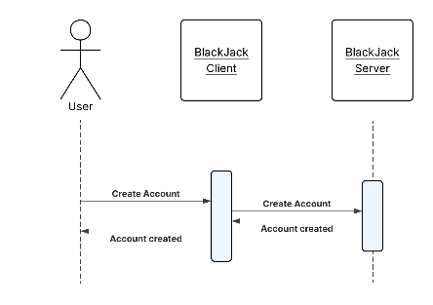
1.2.4.2: Player pre game sequence
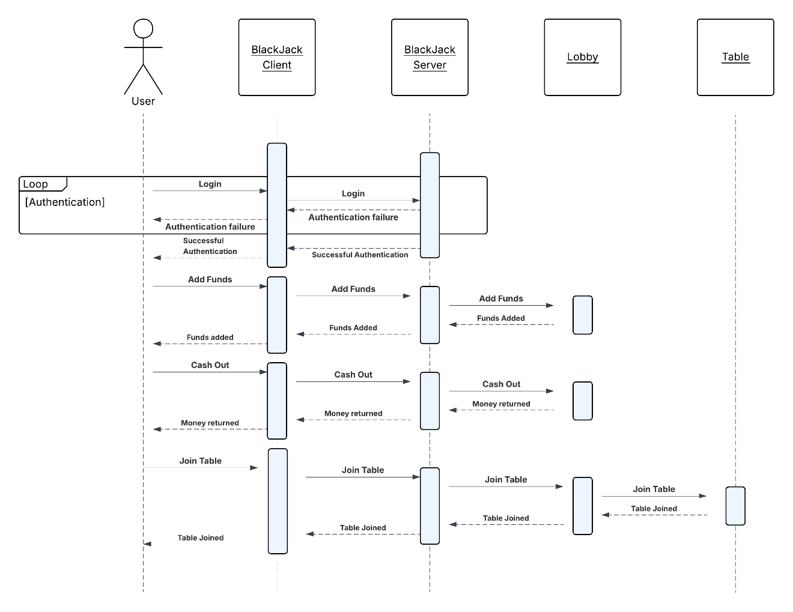
1.2.4.3: Dealer pre game sequence
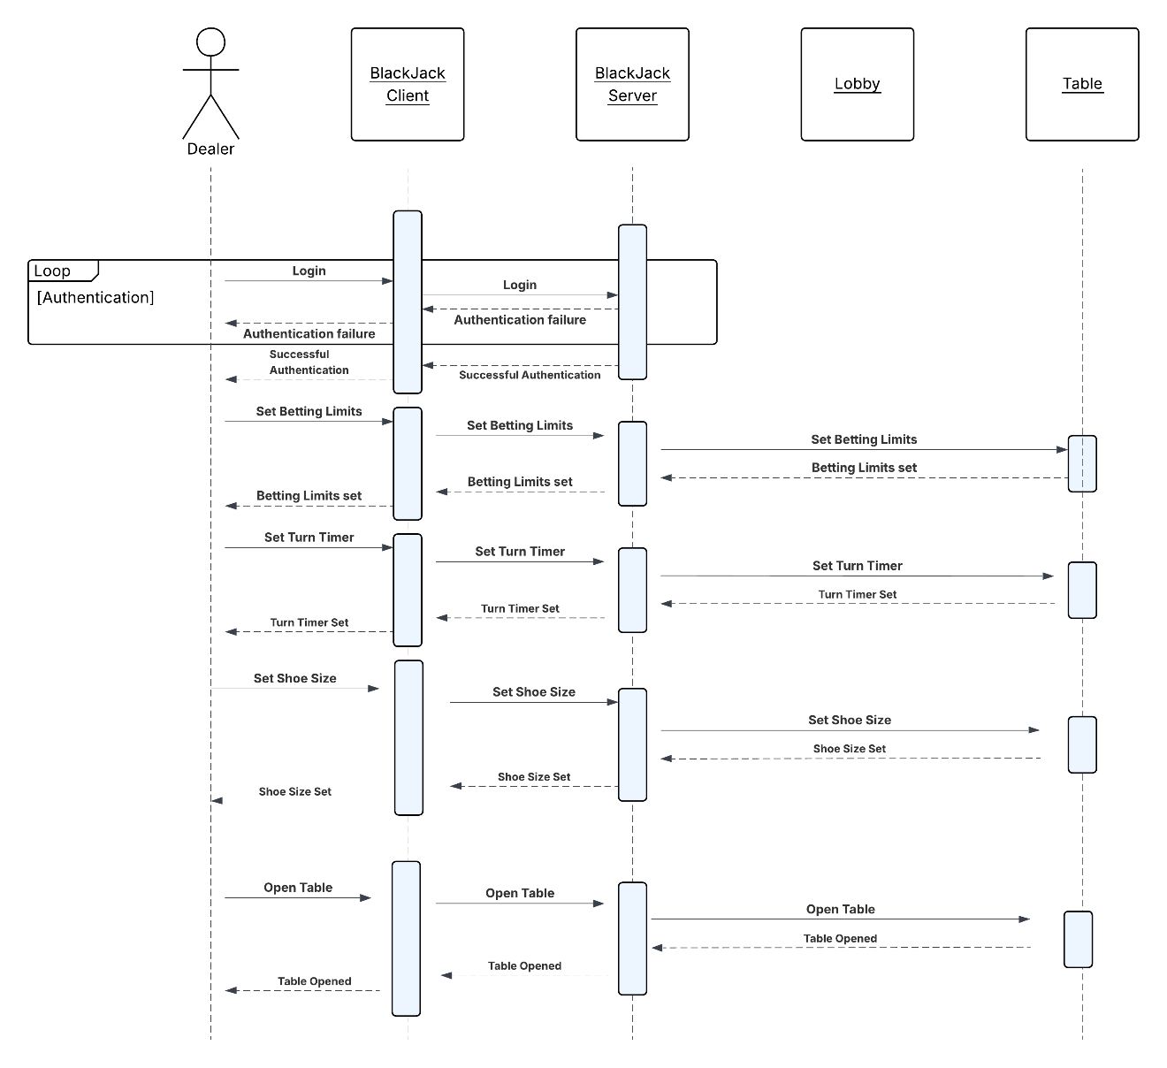
1.2.4.4: Player in game sequence
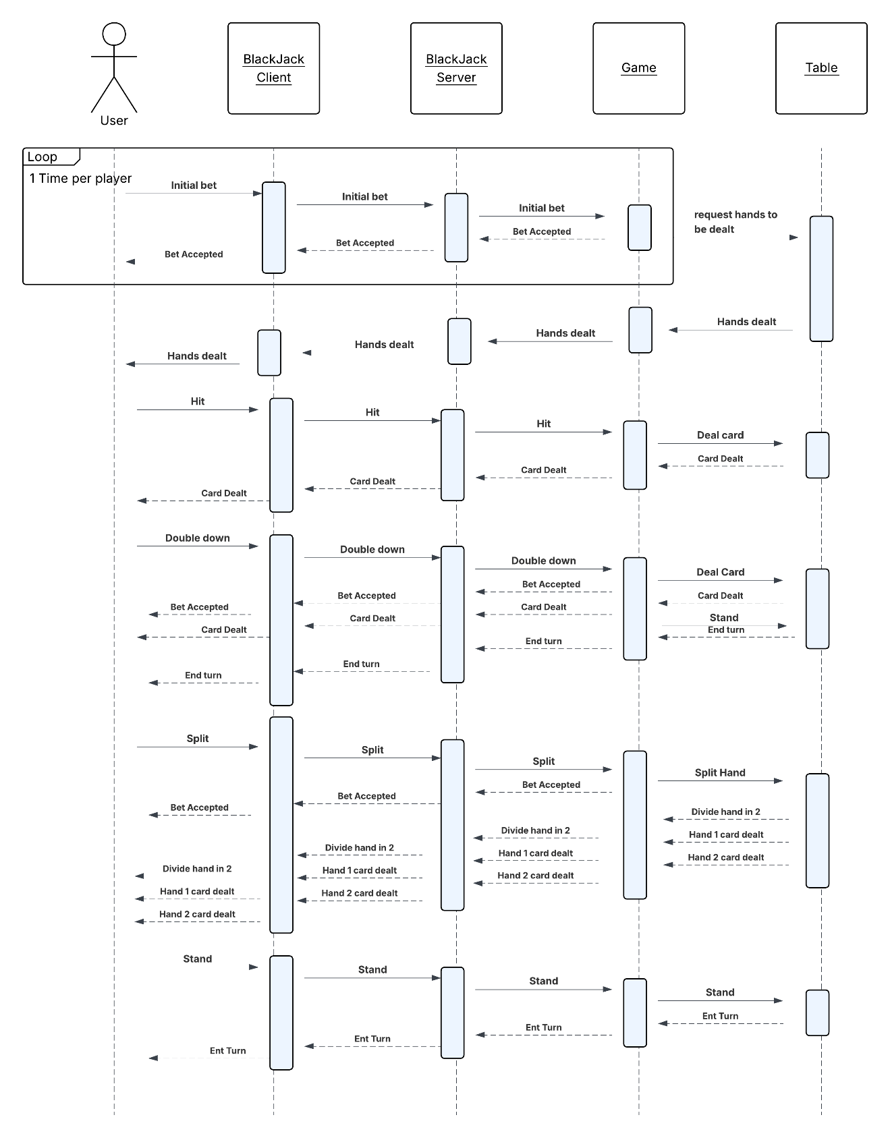
1.2.4.5 Dealer in game sequence

Overview
1.3.1 The Blackjack Handling System is designed to facilitate multiplayer games of Blackjack. Live players as both regular users and dealer players with privileges to deal cards will be hosted on tables for games.

Overall Description

Product Perspective
2.1.1 This is a multiplayer blackjack java application that uses a client/server architecture for networked gameplay. The client will provide the GUI for the login, lobby, and the tables for playing and facilitating separate player and dealer actions. Along with maintaining the game state for the duration of a table being live, the server program enforces the standard rules for blackjack play. The server will also persistently store the user account credentials and credit balances for each account. Communication for the networking occurs over TCP/IP and this system assumes a server to be run before client startup.

Product Architecture
2.2.1 The system will be organized into seven major modules: the network module, lobby/account module, table module, user/login module, storage module, game module, and GUI module.

Product Functionality/Features
2.3.1 Users can log into their accounts with the appropriate roles authenticated, participate as a player with their betting balance or as a dealer. The system further enforces role-based permissions through the allowed actions in the GUI. Players can view available tables in the lobby and choose which table to join while dealers are brought to a table setup configuration before opening a 6-person table themselves.
2.3.2 The system will provide management for the blackjack game in distinct phases: betting, player action, and outcome. Further enforcement of the rules are in the valid player actions they can take with the standard set of blackjack hitting, standing, double down, split, insurance. Dealer actions follow rules as expected from a casino game of blackjack.
2.3.3 The players can add funds to bet with and cash out, with the system validating their bets and ability to participate in the game with enough credits. The client interfaces in real-time with the game state from the server, and the system handles disconnections and re-connections from clients. The GUI enables controls per turn in game and facilitates the actions within an active game alongside external menu actions such as lobby functionality.

Constraints
Java based client/server application with no web interfaces.
All participants must have network access configured to allow them to communicate with the server.
The server must have network access configured to allow it to communicate with the clients.

Assumptions and Dependencies
Any users will have a functioning network connection and a recent version of java installed in order to be able to play the game.
Each table has a limit of 6 players plus the dealer.
To prevent games from slowing down, a standard 30 second timer per decision will be implemented, though this is configurable by the dealer. When the time limit is reached, the current player will automatically stand.
If the player loses access to the game during play, they will automatically stand when the time limit is reached during their turn. Any bets that were active at the time will go to the house if the player loses or be returned to the players account if they win.
Players can only be logged into one player session at a time.

Specific Requirements

Functional Requirements

Common Requirements:
3.1.1.1 Users should be allowed to log in using their personal username and password credentials, comprised of alphanumeric characters
3.1.1.2 The system shall verify user credentials with records stored on the server before allowing access to any system functionality.
3.1.1.3 The system shall prevent unauthenticated users from accessing the lobby, tables, or gameplay features.
3.1.1.4 The system shall identify the authenticated user role as either player or dealer and apply the appropriate permissions.
3.1.1.5 Users may only have one active session logged into the system at a time.
3.1.1.6 The system shall maintain the authenticated session while the user remains connected to the server.
3.1.1.7 If a user disconnects or logs out, the system shall terminate the session and require the user to log in again to regain access.
3.1.1.8 The system shall display an error message when a login attempt fails due to incorrect credentials.

Users Module Requirements:
3.1.2.1 Users should be allowed to log in using their created user id and pin, both of which are alphanumeric strings between 6 and 20 characters in length.
3.1.2.2 Users must login either as a dealer or a player.
3.1.2.3 Users must enter the IP address in order to join the lobby
3.1.2.4 After logging in, players will be sent to the lobby. Dealers will be sent into a separate menu where they can open a new table.
3.1.2.5 Accounts will be managing credit totals, and will be updated after each bet.
3.1.2.6 Accounts will be assigned a role whether they are a player, dealer or developer.

Datastore Module Requirements:
3.1.3.1 Data such as user credentials or personal information like payment method will be stored with on the server with no access from the client program with the exception of an authenticated successful user login capable of viewing the specific information tied to their ID.
3.1.3.2 Updates such as the current balance from one’s user account will be accessible in real time, following with game outcomes such as lost or won bets.

Network Module Requirements:
3.1.4.1 The system shall allow client applications to establish a TCP/IP connection with the server before accessing any game features.
3.1.4.2 The server shall maintain persistent connections with all active client sessions during gameplay.
3.1.4.3 The network module shall transmit player actions (hit, stand, bet, split, double down, insurance) from the client to the server.
3.1.4.4 The server shall broadcast updated game state information to all clients at a table after each player action.
3.1.4.5 The network module shall detect client disconnections and notify the server.
3.1.4.6 If a client disconnects during gameplay, the server shall maintain the player's game state until the round is completed.
3.1.4.7 The network module shall allow disconnected clients to reconnect and resume their session if the round has not yet completed.
3.1.4.8 Network messages exchanged between client and server shall contain only gameplay data and required session identifiers.
3.1.4.9 The server shall reject connection attempts from clients that are already logged in from another session.

GUI Module Requirements:
3.1.5.1 For the three distinct areas of the game client users interact with, the GUI will provide the proper actions and notifications based on what is happening and the role of the user.
3.1.5.2 Between all the other classes and modules, the GUI will facilitate signals and communication between the client and server by relaying user actions and input alongside server responses and behavior.
3.1.5.3 The GUI will display the relevant information for different scenarios like phases of the game or differing timings and specific actions.
3.1.5.4 During events such as player disconnections, table closures via dealer disconnection, or other abrupt ends to rounds and games the GUI will provide a notification indicating that the round in progress will complete before the remaining online users at a table are brought back to the lobby screen.
3.1.5.5 The GUI will be providing real time input and signals for the client programs to send to the server for the functions outlined in each layer of the game client interface.
3.1.5.6 With role-based permissions between the player and dealer user type, the GUI will display the relevant accessible commands and information to each respective user after proper authentication on login.
3.1.5.7 While actions may not be available depending on the game state or phase, the GUI will communicate that the player is still connected and consistently display the active happenings of the table.

Lobby Module Requirements:
3.1.6.1 Players will be sent to the lobby after logging in.
3.1.6.2 Players will be able to deposit and withdraw money from the lobby.
3.1.6.3 Players will be able to join any open table from the lobby
3.1.6.4 Players will be able to see table options and rules from the lobby.

Table Module Requirements:
3.1.7.1 Tables are created whenever a dealer joins the server
3.1.7.2 Tables are opened whenever the dealer finalizes the table options
3.1.7.3 Table options are as followed: setting betting limits, setting shoe size, setting the turn timer.
3.1.7.4 Players must have the minimum bet in order to join the table
3.1.7.5 The dealer can close the table at any time. When the dealer sets the table to be closed, the game continues until the current round is complete.
3.1.7.6 Each table will have a maximum of 6 players and 1 dealer.
3.1.7.7 Table will be locked from new players while the table is at max capacity.

Game Module Requirements:
3.1.8.1 Setup player and dealer controls to accommodate game play and flow.
3.1.8.2 Players must have sufficient credits in order to place a bet
3.1.8.3 Turn time limit will be enforced in order to facilitate game flow
3.1.8.4 Players must select an action within the turn time limit. If not, player stands.
3.1.8.5 Players will be able to select from the following actions during their turn: hit, stand, double down and split.
3.1.8.6 All players must complete their turn before the dealer can play their hand.
3.1.8.7 Dealer can offer insurance when they show an Ace. Player must pay an additional 50% of their original bet. If dealer has blackjack, player receives 2:1 from insurance. Else the player would lose the additional 50%.
3.1.8.8 Players and Dealer bust when their hand value is over 21
3.1.8.9 If the player’s hand value is greater than the dealer, but less or equal to 21, they win.
3.1.8.10 If the player and dealer tie, bet is returned.
3.1.8.11 If any player has a blackjack, they beat the dealer unless the dealer also has blackjack.
3.1.8.12 If a player has a blackjack and wins, player gets 1.5x their bet
3.1.8.13 Dealer must hit if their hand value is under 17

External Interface Requirements
3.2.1 The system shall provide a graphical user interface for all user interactions including login, lobby navigation, table joining, and gameplay actions.
3.2.2 The GUI shall present buttons or controls for player actions including hit, stand, split, double down, and insurance when available.
3.2.3 The GUI shall display real-time updates of the game state including player hands, dealer hand, bets, timers, and outcomes.
3.2.4 The system shall provide user interface elements allowing players to deposit funds, withdraw funds, and view current credit balances.
3.2.5 The GUI shall display available tables within the lobby including table rules, current player count, and betting limits.
3.2.6 The GUI shall notify users of connection issues, disconnections, or server shutdowns.
3.2.7 The system shall interface with user payment methods (credit cards) to allow the purchase of in-game credits.

Internal Interface Requirements
3.3.1 All gameplay calculations must be performed on the server and only relevant data to each play must be sent to them.
3.3.2 User ID and passwords will be stored, along with current funds and active bets so that they can be restored in the event of any outage or system failure.

Non-Functional Requirements

Security and Privacy Requirements
4.1.1 All user accounts must use non-sensitive ID/password combinations as encryption will not be used and will be visible to developers.

Environmental Requirements
Example:
4.2.1 System cannot require that any software other than a web browser be installed on user computers.
4.2.2 System must make use of the University’s existing Oracle 9i implementation for its database.
4.2.3 System must be deployed on existing Linux-based server infrastructure.

Performance Requirements
4.3.1 While we hope for significantly more, for demonstration purposes the server should be able to handle the workload for at least four tables and fifteen users at speeds comparable to real world blackjack tables found in any casino.

